Sample Technical SEO Audit

Purpose of SEO Technical Audit

The purpose of this report is to review the CLIENT website and provide specific recommendations to help improve SEO rankings, website performance and overall user experience.

Overall Traffic

Overall Site Traffic Sessions

We have pulled SEO traffic information for the last three full months. This data, obtained via HubSpot, is as follows:

Overall Site Traffic Sessions
October 2020 | November 2020 | December 2020
2,459 sessions | 2,231 sessions | 2,444 sessions

From October 2020 to December 2020, the CLIENT website saw 7,134 sessions of overall traffic. Traffic does not appear to be growing, but remains fairly consistent over the months, except for a slight drop in November.
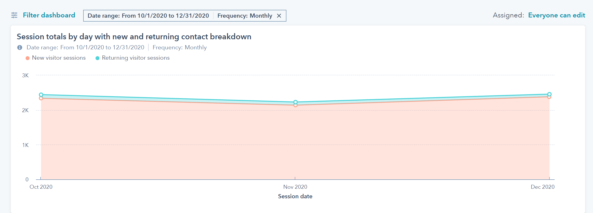

The average session duration, pages per session and bounce rate are all measures of how much users tend to engage with the site. Better user engagement metrics indicate users are more interested in the site’s content, meaning they are more likely to aconvert.

Site Metrics - User Behavior and Engagement
We reviewed initial site metrics from the past three months that give us insight into user behavior and engagement. Thus far, we have seen low engagement patterns with an average session duration of 15 seconds. Bounce rate is over 90%. That indicates that the content is not resonating with the audience, there aren’t enough calls to action (CTA), or the site is taking too long to load, which is evident if you review the Site Speed section.

This behavior tells us that visitors are spending a low amount of time clicking around the site and engaging with its content.

Site Metrics - User Behavior and Engagement
SEO Metrics for August 1, 2020 to October 31, 2020
Average Session Duration | Pages Per Session | Bounce Rate
15 seconds | 1.14 pages | 92.95%

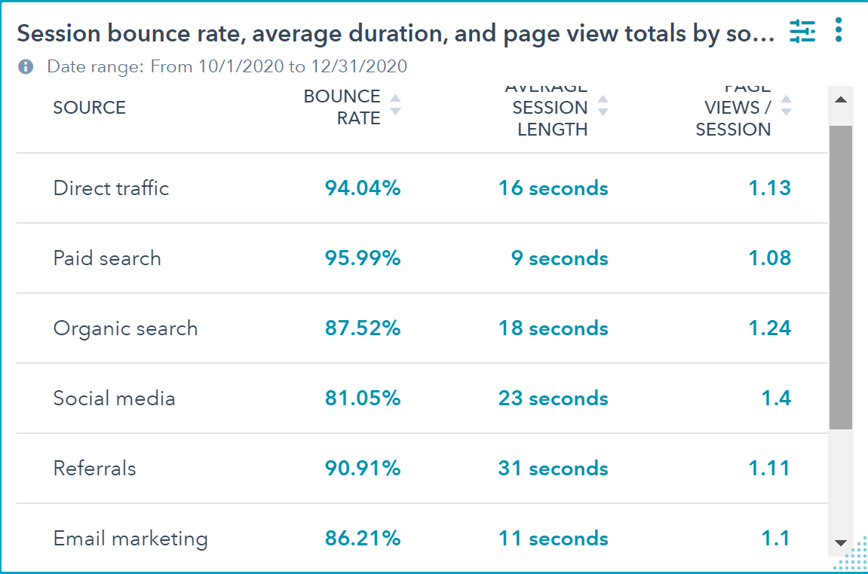
Social media has the lowest bounce rate followed by Email marketing and Organic Search. It’s worrying that Direct traffic has such a high bounce rate since these are people typing in the site directly into the search bar. One observation is that the banner is extremely large on Desktop, and the first clickable element is below the fold. The next clickable elements are way down on the page. Services should be placed higher. Add more clickable elements above the fold to encourage engagement and reduce bounce rate.


Historical Review of Organic Traffic

The graph below shows a 2-year snapshot of the site’s sessions between January 1, 2019 to December 31, 2020. We use this historical view to understand normal trends and variances in site traffic.

For the most part, traffic has remained low, except for a major spike in January 2020 and minor spikes from August to November 2019.

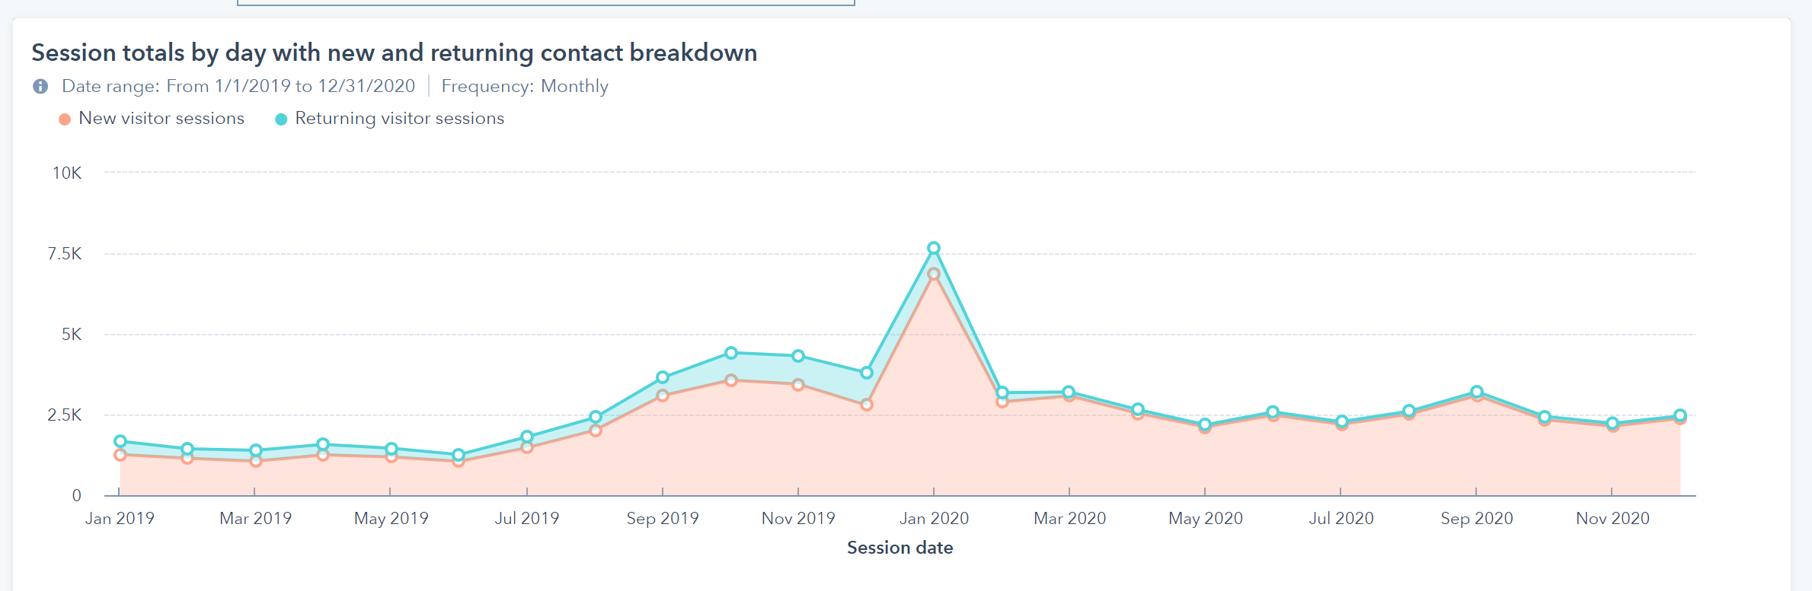
This spike seems to be related to an email campaign that drove a lot of traffic.

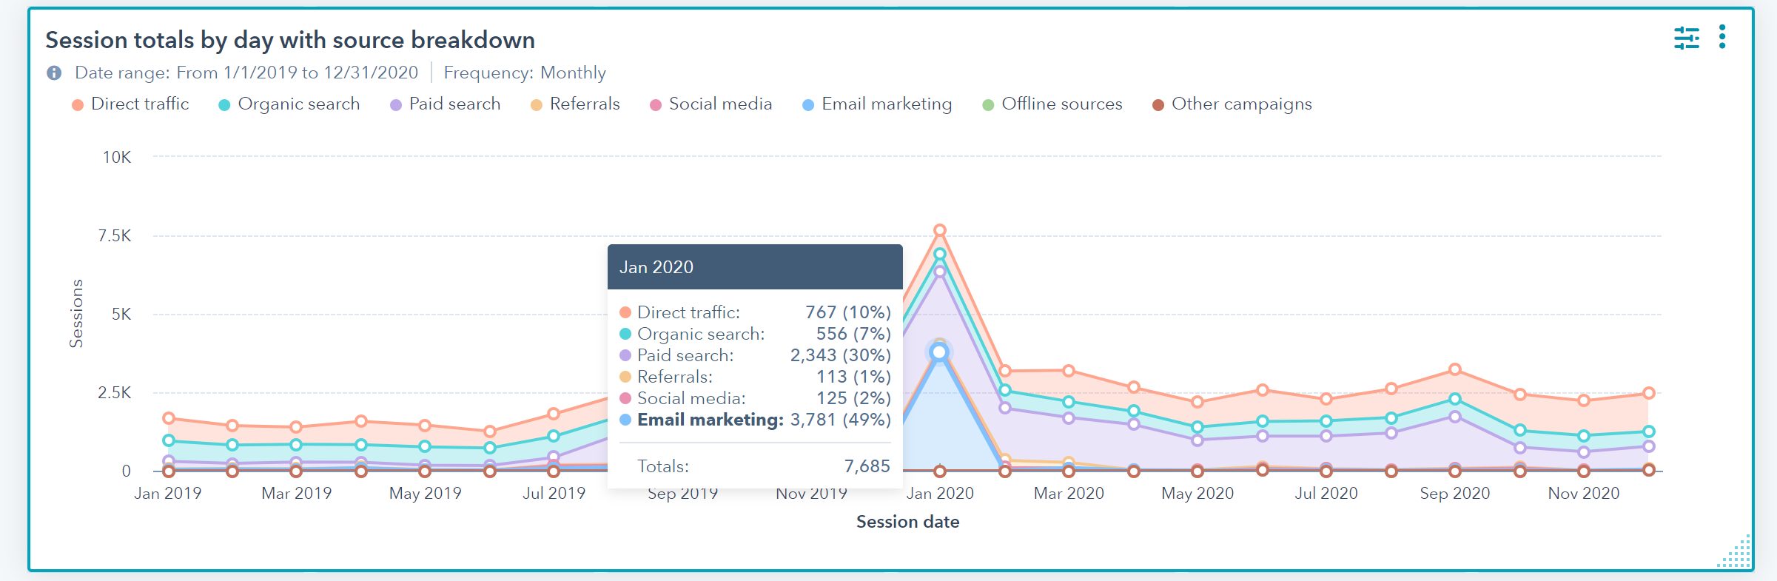
Investing in quality, targeted email campaigns could also bolster overall traffic.

Desktop is driving the majority of traffic, which makes the importance of having clickable, engaging elements near the top extremely important. Mobile is a close second, which means that the slow load time could be affecting traffic.

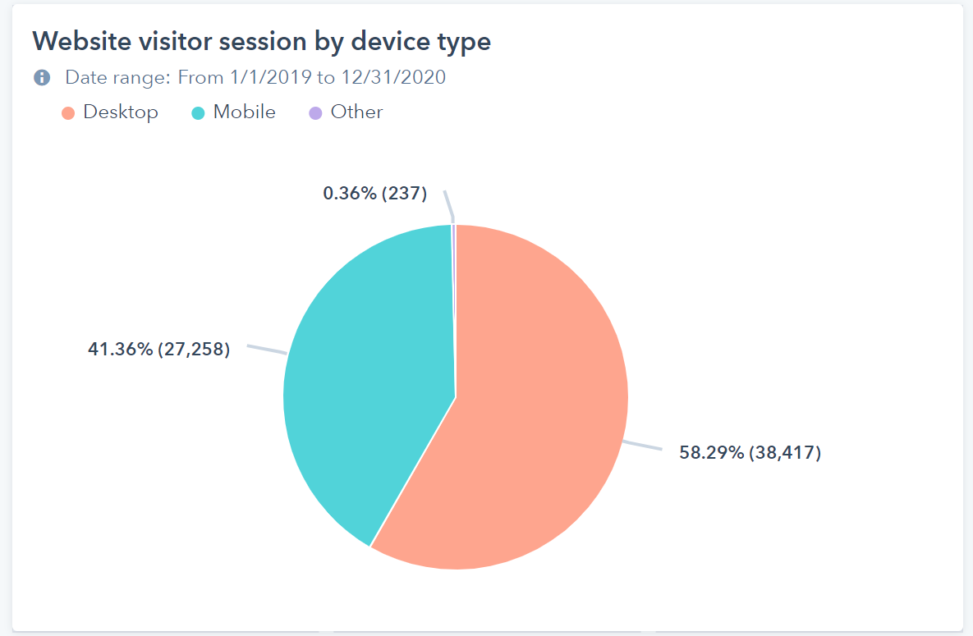

Website Load Time and PageSpeed Insights

Google PageSpeed Insights Tool

Google uses a site’s page speed as part of its ranking algorithm. Using Google’s PageSpeed Insights Tool, we reviewed the website to ensure it meets all the requirements for good Google performance. Any speed below 49 is considered to be poor. Below 90 means that the site needs improvement. On both Mobile and Desktop, your site could be improved.

Mobile Speed
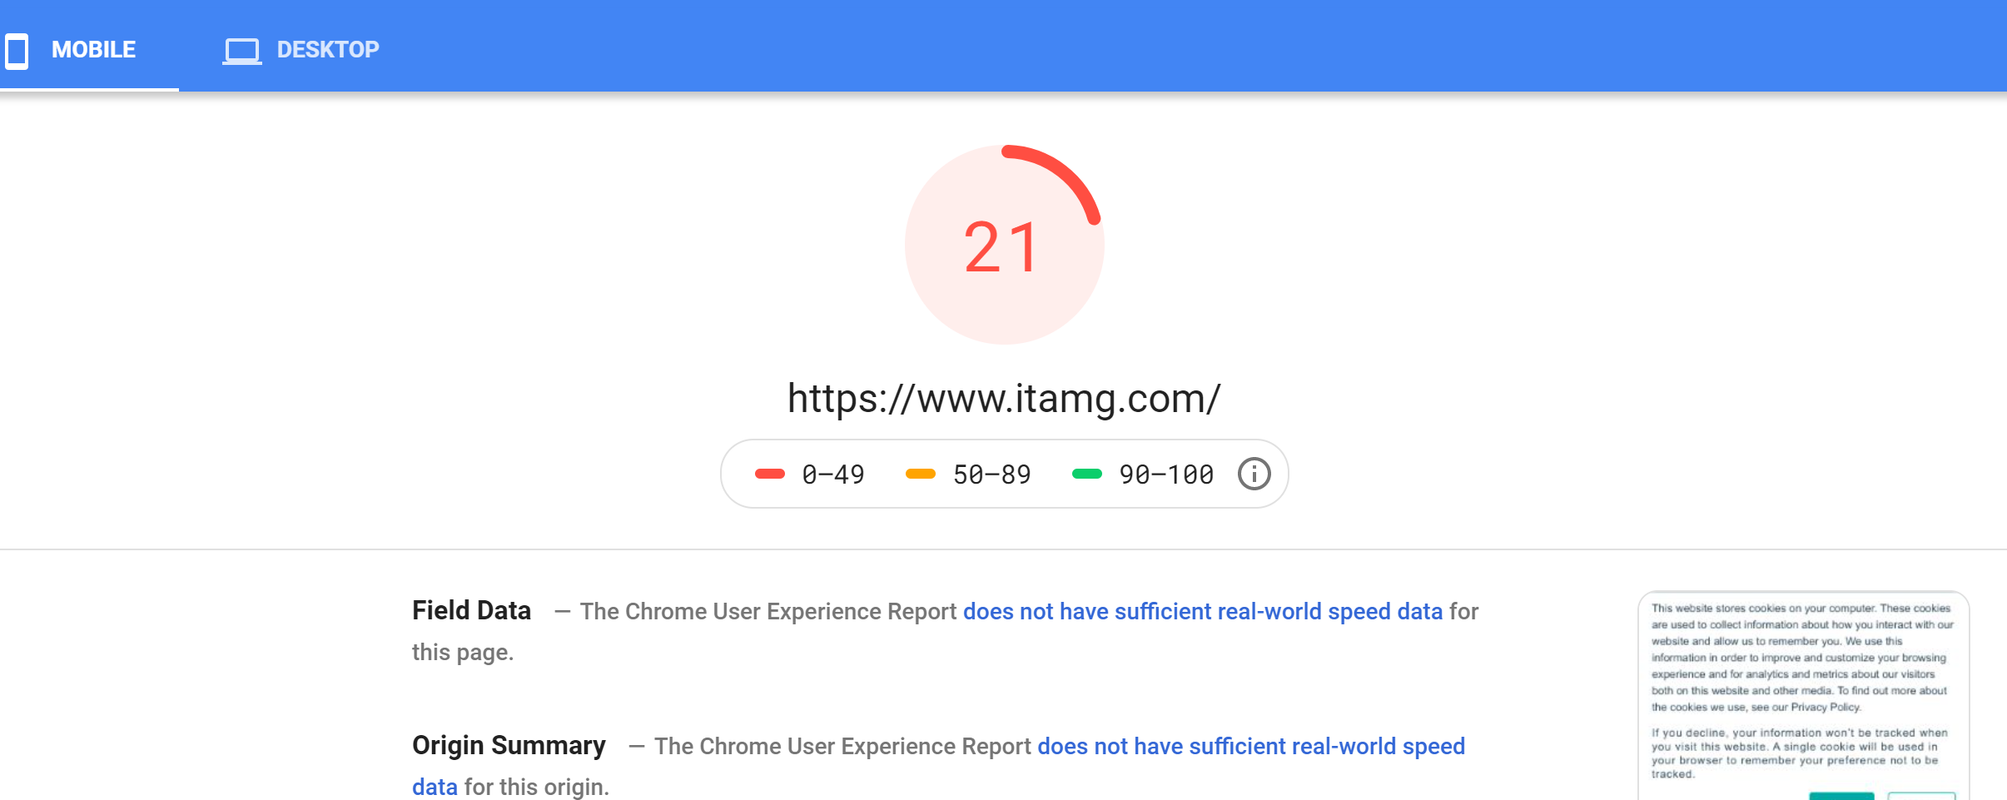
You can see the full report here: https://developers.google.com/speed/pagespeed/insights/?url=https%3A%2F%2Fwww.Client.com%2F
Issues:
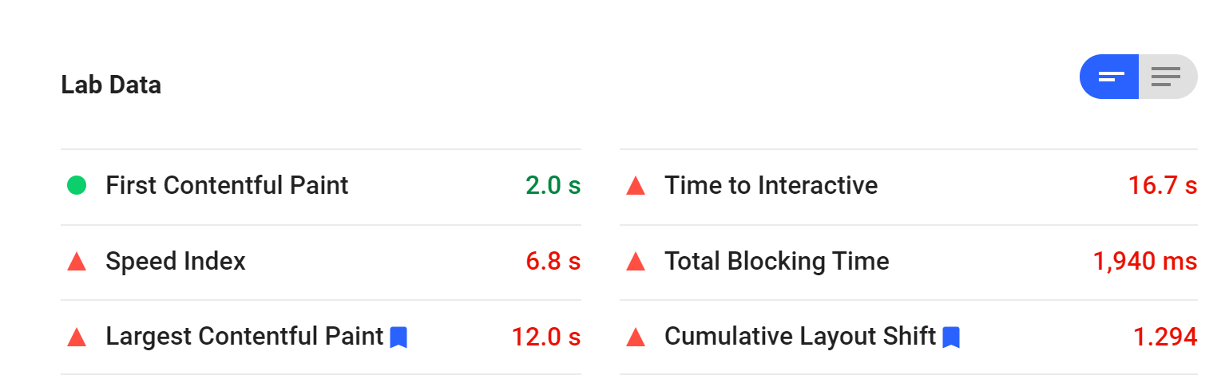

Desktop
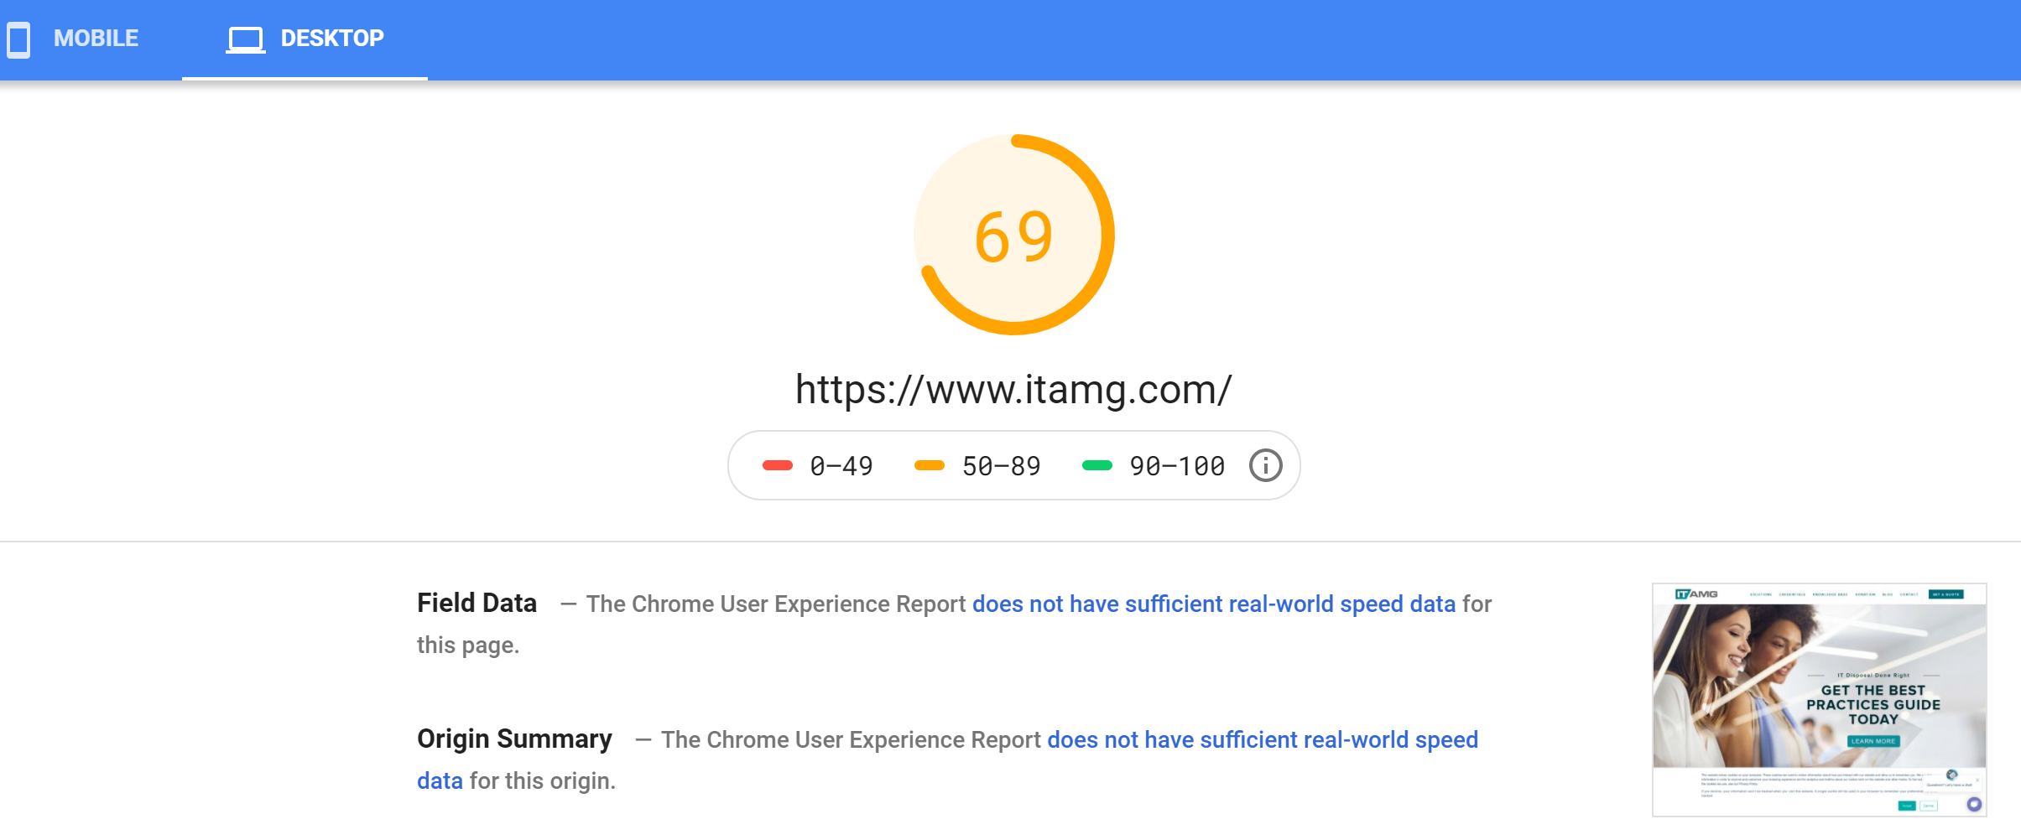
Issues:
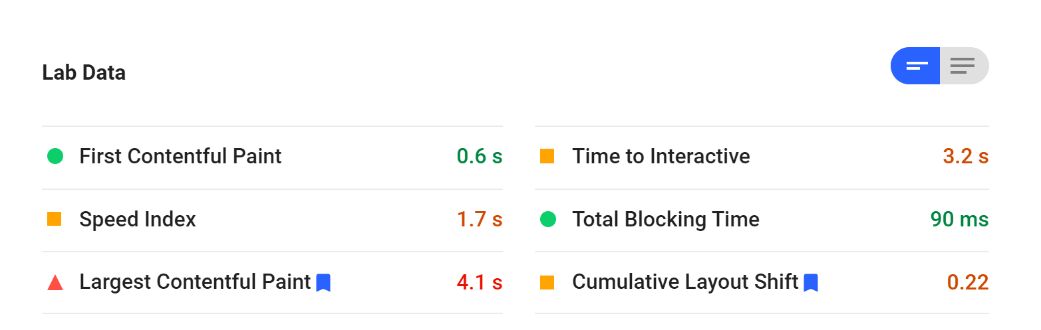
You can see the full report here:
https://developers.google.com/speed/pagespeed/insights/?url=https%3A%2F%2Fwww.Client.com%2F&tab=desktop

Keyword Analysis

SEO Keywords
According to SpyFu, Client currently ranks for 315 keywords with an estimated monthly SEO clicks of 1,020. A total of 38 keywords currently rank on the first page, with most keywords ranking between pages 2 and 10. Your most valuable keywords are as follows:

- Coi
- Cois
- Certifician of Recycling
- ITAD
- Certificate of destruction

Since the main two keywords that you are mainly using are IT asset disposal and IT asset recycling, neither one of these have high search volume.
Other focus keywords include:
- computer disposal
- new york it equipment disposal
- ITAD
- hard drive disposal
- computer liquidation
- new york itad
- laptop liquidation
- it asset disposal
- computer liquidators
- itad companies
- it disposal
Of all of these, ITAD (1,600 avg. monthly searches) and computer disposal (1,300 avg. monthly searches) have the highest search volumes, but they still don’t have a lot of searches.
If you believe that they will be trending keywords in the future, then you need to focus on adding these to your current content and meta tags, and devising an SEO strategy to better rank for these important keywords since you currently don’t rank very well at the moment. Creating content (blog specifically) around your major themes will improve rankings.
We recommend doing additional keyword research to find keywords that currently have high search volume to better find visitors. For example, “computer recycling” gets 9,000 avg. monthly searches.

Paid Keywords
According to SpyFu, you are currently ranking for 16 paid keywords. None of these have high search volume. In fact, “recycling computers” has the highest at 930 avg. monthly search volume. Your other top keywords include electronics disposal NYC, computers liquidation, new york computer recycling and disposing of electronics NYC. We would recommend additional keyword research to open up your keyword universe.

Technical SEO Issues
Canonical Tags
The main blog page is missing canonical tags. Canonical tags alert search engines that this is the “main copy” of a page, ensuring that no one takes credit for your content. Canonical tags also indicate that a page is the main page if you have several pages with duplicate content. While duplicate content isn’t as bad of a ranking factor as it once did, adding a canonical tag to a main page reduces the instances of duplicate content.
500 Errors
500 errors indicate that you have an internal server error. Currently, a blog page is creating this error: http://blog.Client.com/blog. Please fix the error.
404 Errors
404 errors indicate that a page cannot be found. These provide a poor user experience as well as affect your SEO rankings.
You can find the full list of 404 errors here: https://drive.google.com/file/d/1PLMTtULONryJDFpQqod4V8loKnRkzgzy/view?usp=sharing.
Page Titles
Title (page) tags are displayed on search engine results pages (SERPs). Not only do they alert SERPs as what the page is about, it's an opportunity to leverage keywords to help you rank for them. Each page title should be unique, and each should be different from the H1 tag - even if it’s just slightly different. Page titles that are 60 characters or less will typically show fully in SERPs, but they can be as long as 70 characters depending on the platform. Using the full length of characters provides more opportunity to explain what the company does and use targeted keywords.
Page titles should be unique since they help search engines determine what a page is about. Currently, you have several page titles that are exactly the same.
You can see the full list here: https://drive.google.com/file/d/1GSCdItR-0AB0y1BP40ixslEfPdxWpf1b/view?usp=sharing.
Page titles should be 70 characters or less to show up in their entirety in search results. These following items should be reduced to ensure they meet character lengths.
Address | Title 1 | Title 1 Length
https://www.Client.com/askitad/why-should-we-be-concerned-about-compliance | Why should we be concerned about compliance if our business is not in finance, healthcare, or otherwise not subject to existing data protection regulations? | 156
https://www.Client.com/askitad/company-be-held-legally-responsible-for-a-vendor-failure-to-comply-with-regulation | Can my company be held legally responsible for the failure of my vendor to meet regulatory guidelines? | 102
https://www.Client.com/askitad/which-data-destruction-methods-are-compliant | What methods of data destruction are required by regulations such as GLBA, HIPAA, SOX, or HITECH? | 97
https://www.Client.com/askitad/can-a-person-be-held-responsible-for-failure-to-comply-with-hipaa-data-security-regulation | Can a person be held responsible for failure to comply with HIPAA data security regulation? | 91
https://www.Client.com/askitad/can-a | Can leadership be held personally responsible for failure to comply with GLBA? | 78
https://www.Client.com/askitad/client-faq/data-security/why-do-i-have-to-clear-or-provide-bios-admin-or-similar-firmware-passwords | Why do I have to clear or provide BIOS, admin, or similar firmware passwords? | 77
https://www.Client.com/askitad/do-you-have-a-minimum-quantity-of-items | How many items do I need to have? Is there a minimum to schedule a pickup? | 74
https://www.Client.com/blog/the-repercussions-of-the-poor-electronic-recycling-decisions-of-our-past | The Repercussions of the Poor Electronic Recycling Decisions of our Past | 72
https://www.Client.com/blog/4-lessons-from-star-wars-about-data-destruction-and-it-asset-liquidation | 4 Lessons from Star Wars About Data Destruction and IT Asset Liquidation | 72
https://www.Client.com/askitad/how-to-transfer-regulatory-liability | How can we transfer data protection regulatory liabilities to a vendor? | 71

Page titles also shouldn’t be too short. At minimum, they should be at least 55 characters. Making them longer allows you to use your keywords within the meta tags.
You can see the full report here: https://drive.google.com/file/d/1tfEtk87LVthpuJYfal13B7ZEfRa9-mjx/view?usp=sharing

On-Page SEO Elements
Many of the pages and posts do not appear to take advantage of basic on-page SEO techniques.
The pages contain the proper html elements. However, they do not appear to be optimized for SEO by having unique keywords written into them.
It’s considered standard practice to choose a keyphrase and then repeat it in the title, meta description, a header and at least once in the text of the post. For blogs, adding the keyword to the URL is also helpful.

Meta Description
Meta descriptions and title tags are what are often shown in the results pages on Google. Therefore, they should be written in a way to entice readers to click on them. These should also contain targeted keywords. They should be within 155 to 165 characters.
Many of your pages are missing meta descriptions. View the full report here: https://drive.google.com/file/d/1YmwgR0WDvLksYHkoS9MYoeAALfn7XLuy/view?usp=sharing
A handful of pages have the same meta description. Changing them up a bit will help potential visitors distinguish between pages.
https://www.Client.com/contract-rfi: Contact us today to learn more on how we can be your prime IT asset disposal contractor.
https://www.Client.com/data-destruction-consultation: Contact us today to learn more on how we can be your prime IT asset disposal contractor.
https://www.Client.com/program-consultation: Contact us today to learn more on how we can be your prime IT asset disposal contractor.
For example, this last one could be changed to: Our program managers can help you build a custom asset management solution or fill the gaps in your current disposal program. Schedule a free consultation.

Header Tags
Header tags in posts should contain targeted keywords. It appears that there are pages on the site that do not have any keywords in the header tags. H1 tags are another important indicator of on-page content and should be used alongside Page Titles. H2 tags help break up content, improving readability, and also allow you to leverage primary or even secondary keywords.
H1 Titles Same as Page Title
As mentioned above, these two elements should be slightly different. You have several pages where the H1 title is the same as the Page Title. View full report here: https://drive.google.com/file/d/1Zw1Wl7IprB7CkyZMsUJbYGDm6jmdAxQz/view?usp=sharing.
Missing H1 Tags
Many of your blog pages don’t have H1 tags. If you do not wish to manually create H1 tags, you could have these automatically pulled from the name of the blog. While this probably wouldn’t distinguish it from the Page Title, at least you’d have an H1 tag on the page.
View full report here: https://drive.google.com/file/d/1VCWj8MT7GJQPBn-iqQy63eiJyUibYAbH/view?usp=sharing.
Duplicate Content
Your landing pages are showing up as “duplicate content” in the system since they’re very similar to each other. Since these pages are only for campaigns. You should make these pages “no follow, no index” so they’re not cached by search engines.

URLs
The URLs of blog posts and pages should contain targeted keywords where possible. Currently, the URLs are drawn from the full titles of the posts or pages. URLs should also only be around 2,000 characters.

ALT Tags and Image Filenames
It is considered a best practice to create alt tags for images. These ALT tags should contain keyword phrases. In addition, the same keyword phrase should be used in the filename. The filename is also widely considered to be the least influential element of on-the-page SEO so it should not be the priority. Images can show up above other SERP results, allowing you to rank higher than you would for some of your page content.
Images Missing Alt Tags
Some of your images are missing alt tags. View the full report here: https://drive.google.com/file/d/1OerhBxItgw3gmU9YsgYPOBtmWhsV5Q5g/view?usp=sharing

Structured Data
Structured data should be used, if appropriate. Here is a quick explanation of what that means. This is important because Google uses Structured Data to display rich snippets. Rich snippets are the extra data that get displayed with a listing in the search results. Currently, you are not using any type of Schema or similar markup on your site. Create the Organization or Website schema using this tool, and add the code to your backend: https://technicalseo.com/tools/schema-markup-generator/.
Example schema to add to your site:
<script type="application/ld+json">
{
"@context": "https://schema.org/",
"@type": "WebSite",
"name": "Client",
"url": "https://www.Client.com/",
"potentialAction": {
"@type": "SearchAction",
"target": "{search_term_string}",
"query-input": "required name=search_term_string"
}
}
</script>
Here is an example of a site using structured data to display rich snippets.
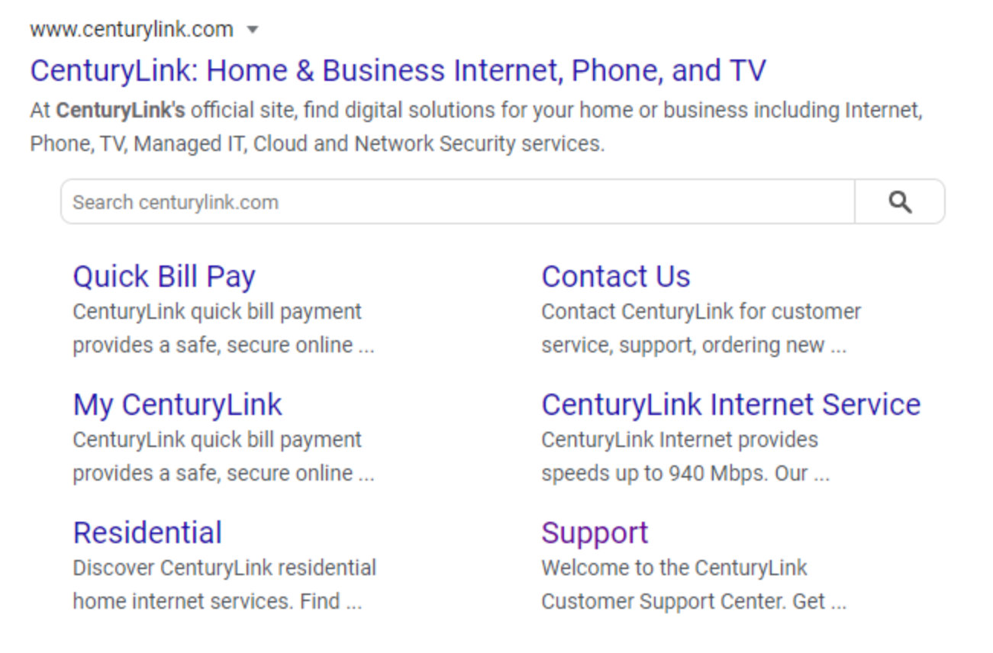

Mobile Friendliness
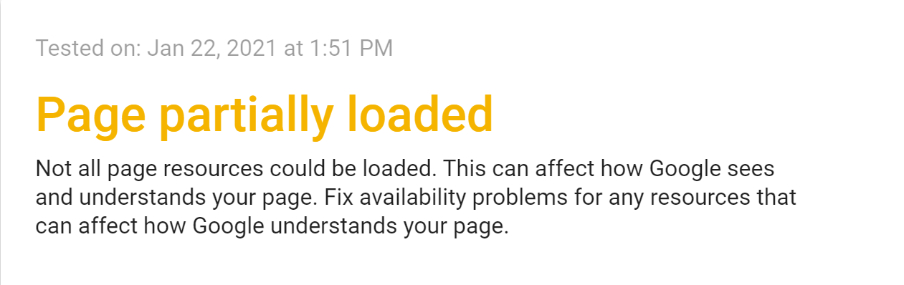
Using Google’s Mobile Usability Testing Tool, we reviewed the main website to ensure it meets all requirements for mobile usability. According to Google’s Tool, the site is considered to be mobile-friendly, but there were some page loading issues. You can see the full details here: https://search.google.com/test/mobile-friendly?view=fetch-info&id=47Zr-5QIzVaiVTo-XdMJhQ. Please address so we can improve the page load.

Individual Page Reviews

Overall Recommendations
Many of your important pages are hidden in the footer menu. For example, About Us and How It Works should really be at the top. Items like Donation and Knowledge Base could be moved to the footer instead.
There are very few CTAs on the pages. You’re missing out on opportunities to encourage people to move through the site or fill out a form so you could follow up with them or add them to email campaigns.
You’re not using your important keywords in either the front- or backend content. This means that your relevancy score with the search engines (how relevant searches engines believe your content is relevant to people’s searches) is rather low. Rewrite the content so that it better reflects your highest searched keywords or trending keywords that you believe will be important in the future.
To assist you with understanding what needs to be done, we’ve provided you with example updates for a sampling of pages.

Home Page
The whole goal of the home page is to drive visitors further into the site. If they can’t find a way to do this, it will increase overall bounce rate. While you do have one button at the top that allows visitors to navigate to other pages (but it is below the fold on Desktop, which means it’s not visible unless someone scrolls), the CTA isn’t strong. “Learn More” doesn’t really tell the visitor why they should go further into the site. Add a revolving banner that features each CTA with a pitch for why someone should click on the button. The next CTAS are way down on the page. And, again, the CTA is “Learn More”. Instead, stronger CTAs like “Maximize Returns Now” or “Recycle Your Electronics Today” would be better.
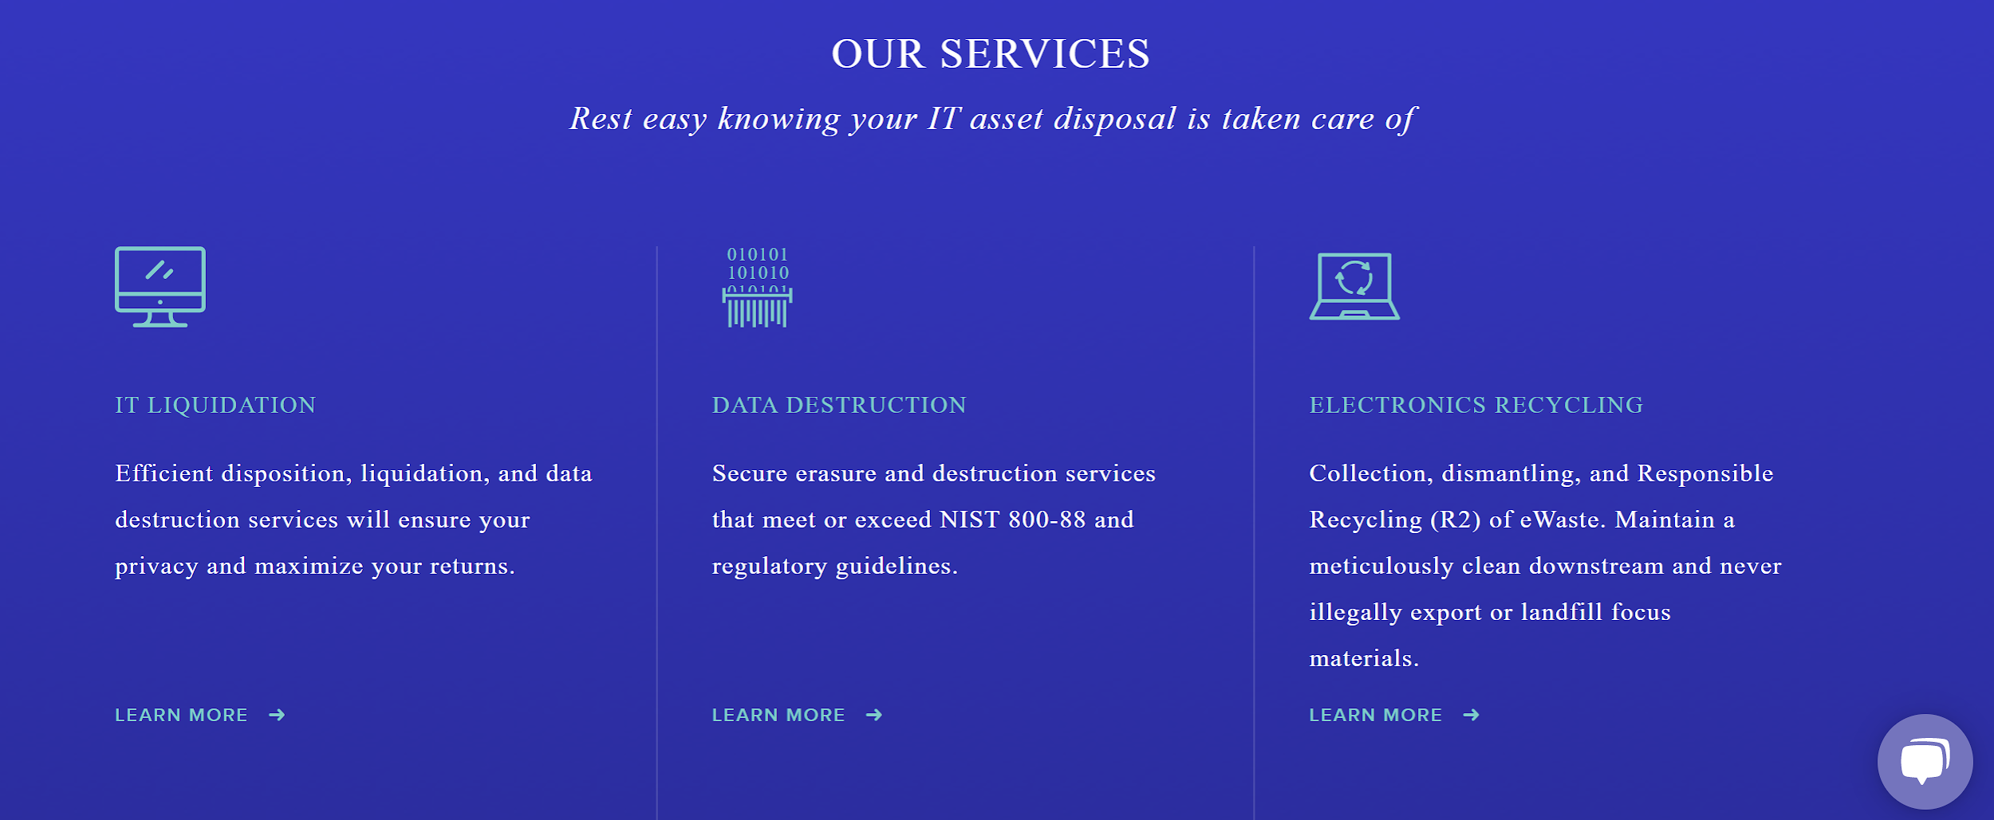

The form fill out is way too far down on the page. You should move the Services and form fill out to the top of the pages. You could even place this as a sidebar.
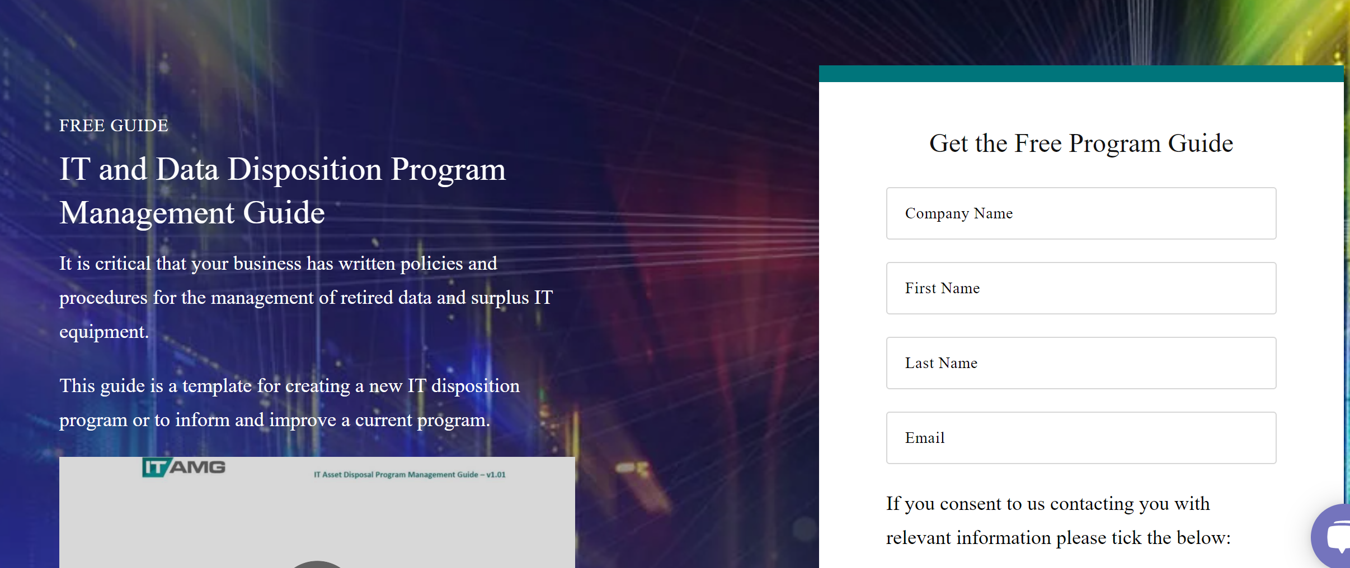

There is no “main” keyword for this page. “ITAD” has the highest search volume at around 1,600. This would be a good keyword to focus on, so mentioning it at the top of the page (in the banner) would be a good practice.

Meta Tags
The meta title is far shorter than the recommended 60 to 70 character limit, meaning that you’re not taking advantage of all the characters. The H1 tag is not very descriptive and does not use any keywords. These are recurring themes throughout all the pages.
Current meta title: Client
Updated meta title: Client: ITAD, Data Destruction & IT Recycling
Current meta description: Get unique IT asset disposal and recycling services that make reselling or upgrading your equipment easy. Our services are fully secure and compliant.
Updated meta description: Get unique IT asset disposal (ITAD) and recycling services that make reselling or upgrading your equipment easy. Our services are fully secure and compliant.
Current H1: Get the best practices guide today
Updated H1: CLIENT: Expert in ITAD, Data Destruction & Electronics Recycling

Solutions Page
Keywords are not used in the content. Content should be updated to reflect the most high-trafficked keywords, including “computer disposal”, “ITAD” and even “computer recycling”. For example, in this section, you could replace “disposal of IT equipment” with “computer disposal and recycling”.
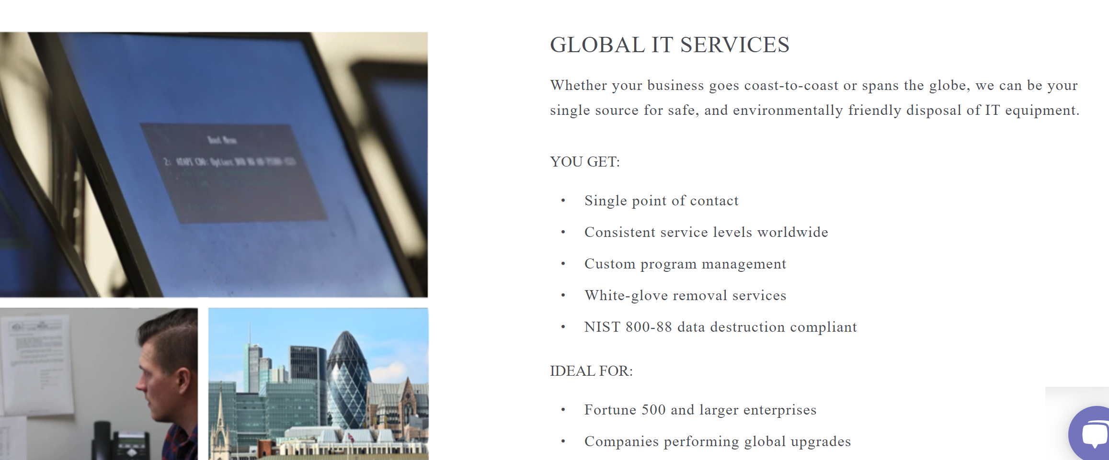
There are no CTAs on the page outside the “Get a Quote” button at the top, which might be missed by visitors. Under each section, there should be a button that visitors can click on to take them to a Contact Us page, Resource, etc. You need to ensure that your audience stays engaged throughout their time on site.

For example, here, the “Get the Free Inventory Workbook” should either be clickable, or there should be a form underneath it.

Overall Recommendations
If possible, Solutions should be broken out into individual pages for SEO purposes. The more pages that a site has, the better chances it has for ranking for target keywords since overall “keyword density” will increase. Pages should link to one another as well as the Product page to ensure that we are driving visitors throughout the site. Meta and H1 tags should reflect what’s on the page as well as incorporate the two main keywords if they are relevant.
URL structure should be shorter than 2,000 characters so they aren’t hard to remember and type into the search bar.
Each section should have a CTA - whether to a resource, demo, contact, etc. - to ensure that we’re encouraging visitors to take action.

Meta Tags
Current meta title: Secure and Environmentally Friendly IT Disposal Services
Updated meta title: Secure & Eco-Friendly Computer Recycling & Disposal Services
Current meta description: Get fullly secure IT disposal services designed to make getting rid of your data and equipment easy and environmentally responsible.
Updated meta description: CLIENT offers fully secure IT disposal and recycling services designed to make getting rid of your data and equipment easy and environmentally friendly.
Current H1: For Your Company’s Specific Needs
Updated H1: Computer Disposal & Recycling Services for the New York Area

Knowledge Base
It would be helpful to have a bit more information on this page. Under each section, either have sample articles or what the person will learn if they click on the “See all articles” link. To make this link more obvious, you should convert it into a button.
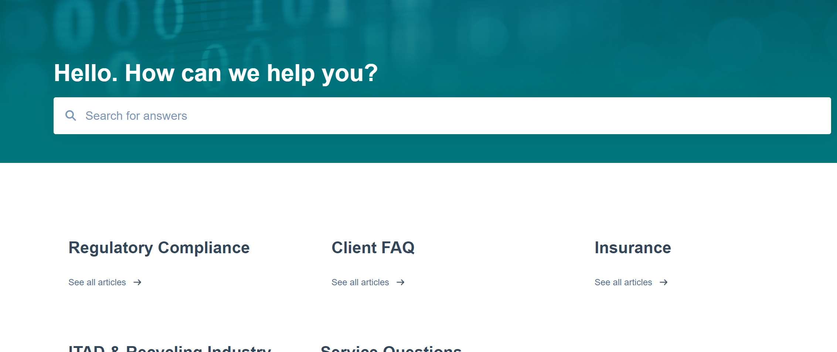

Meta Tags
Current meta title: Ask an ITAD
Updated meta title: Ask an ITAD: Computer Recycling, Disposal & Compliance Knowledge Base
Current meta description: (Missing)
Updated meta description: Got questions about computer recycling and disposal? CLIENT offers a knowledge base to help answer all your questions about the process and regulatory compliance.
Current H1: Hello. How can we help you?
Updated H1: ITAD, Computer Disposal & Recycling & Compliance Knowledge Base

Contact Us
The banner is a bit large on Desktop, which means that a visitor must scroll to reach the form. You could either shorten the length of the banner or move the form to the banner so that it’s more visible.
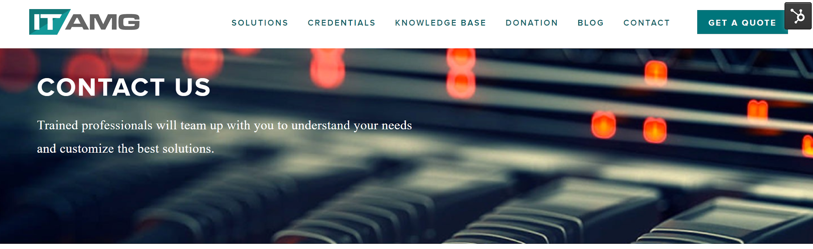
Again, the content doesn’t use any of the most valuable keywords. Adding ITAD or computer disposal would be helpful.
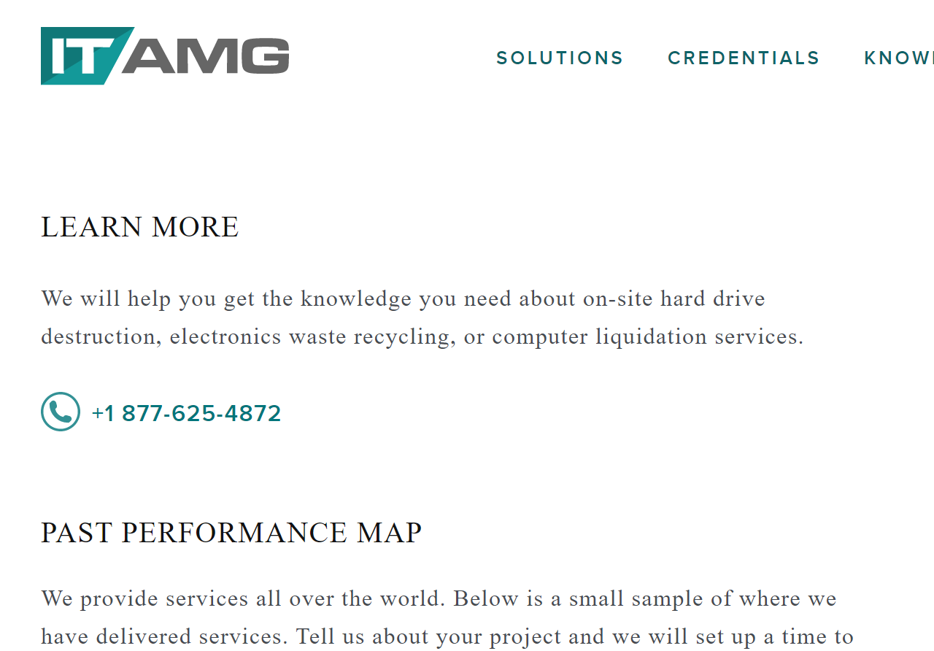

Meta Tags
Current meta title: Contact Us
Updated meta title: Contact CLIENT About Your ITAD, Computer Recycling & Disposal Needs
Current meta description: Contact us via phone and email for a quote or information on how we can aid in your next project
Updated meta description: Want to learn more about our IT disposal and recycling services? Contact us via phone and email for a quote or information on how we can aid in your next project.
Current H1: contact us
Updated H1: Contact Us Now to Launch Your Computer Disposal & Recycling Program

Credentials
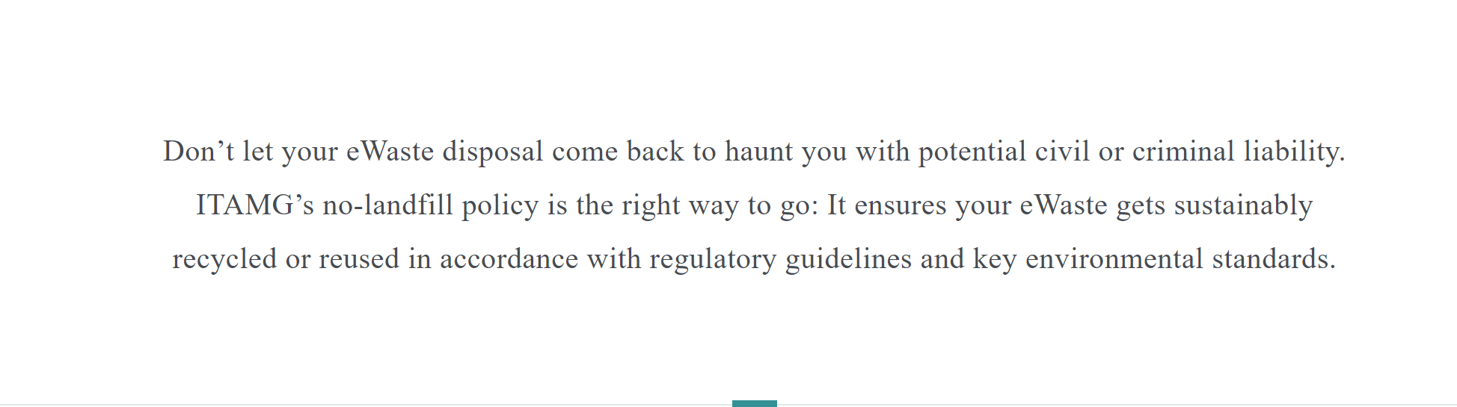
While there’s a lot of solid content on these pages, we’re missing CTAs on the first half of the page. You could add a button that indicates that you can assist with this.
For example, this link could be moved up closer to the top.

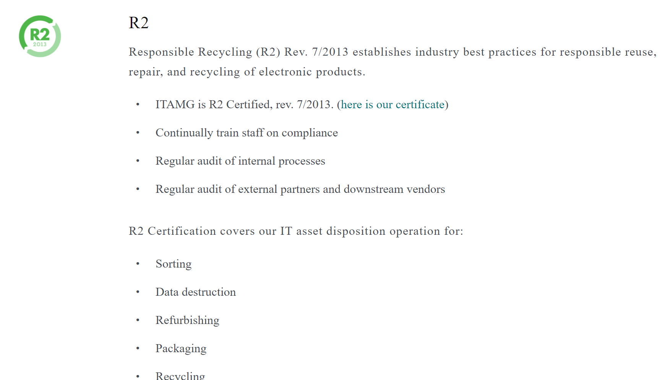
The CTAs like (here is our certificate) are hard to read. Making these more obvious with buttons or even bolded within the text would ensure that visitors see them. Linking to other website content (internal linking) is quite good for SEO, but you need to make the links more visible to a quickly scrolling reader. For the most part, you do a lot of internal linking on many pages, but you need to ensure that each page has at least two to three links to other web pages/content.

Meta Tags
Current meta title: e-Waste and Electronics Recycling Policies
Updated meta title: e-Waste, Computers & Electronics Disposal & Recycling Policies
Current meta description: All of our work is performed to minimize e-waste and conform with gloabl recycling policies. See where our certifications and experience lies.
Updated meta description: All of our work is performed to minimize e-waste and conform with global computer asset recycling and disposal policies. Learn more about our experience now.
Current H1: THE RIGHT WAY TO RECYCLE&nbsp;eWASTE
Updated H1: Learn the Right Way to Recycle IT Assets, eWaste & Computers

About
Most of the content on this page is in bullet form. While that might be good for most other pages, the About page should tell your story: why you started the business, what’s your business philosophy, what sets you apart from competitors, info about the executive team, etc. You mention some of this in the Mission and Goal area, but making this more like a “story” would be more interesting to the reader.
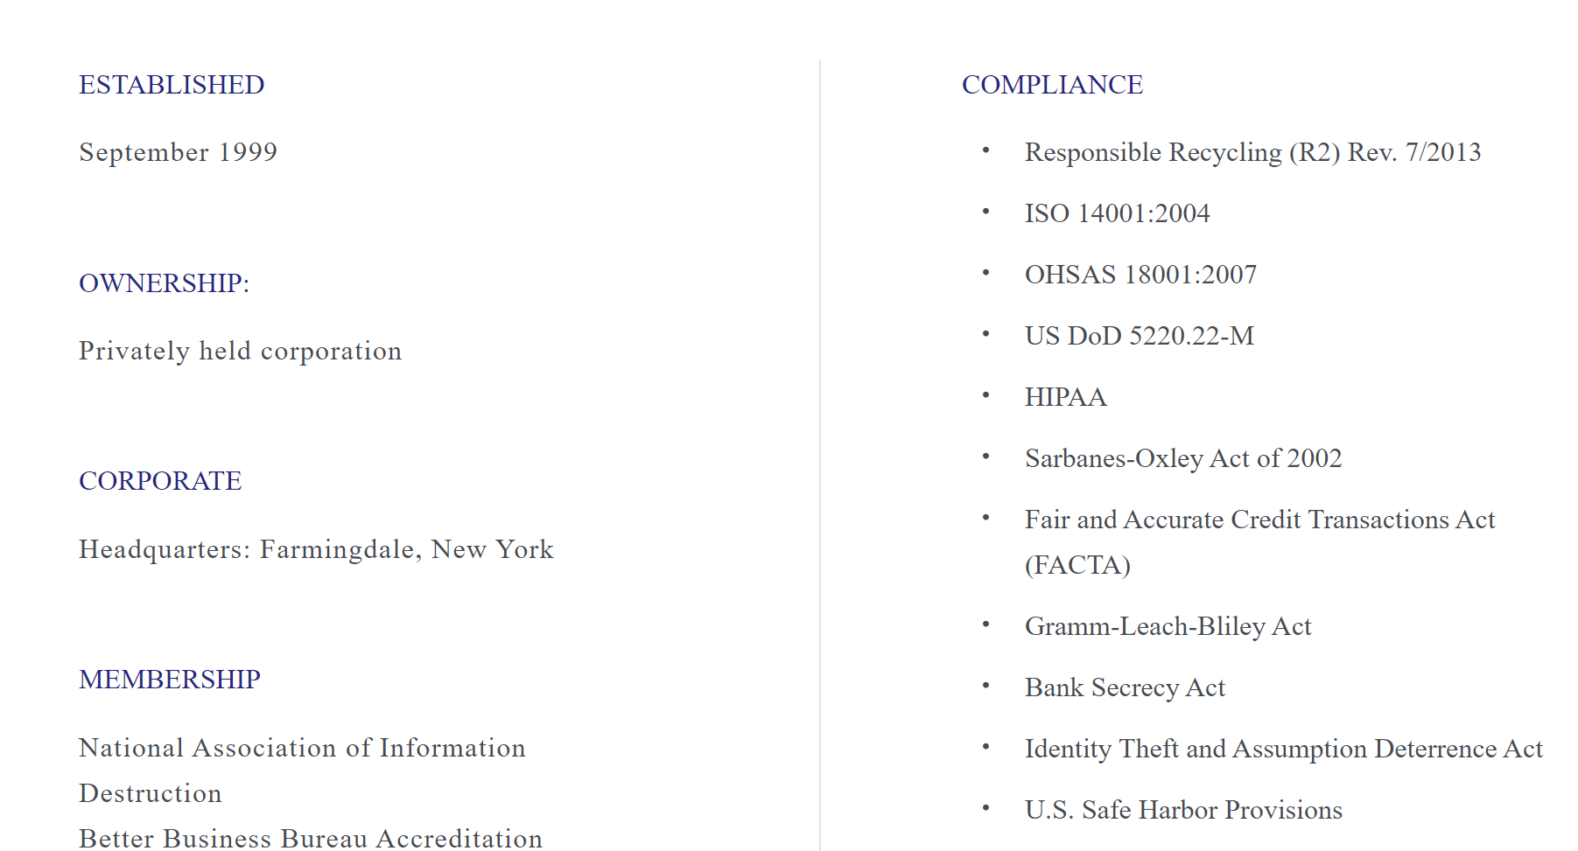

Meta Tags
Current meta title: About Us
Updated meta title: About CLIENT: New York-Based Computer Disposal & Recycling Company
Current meta description: CLIENT is based in New York and has been serving businesses since 1999 - read more about our story here.
Updated meta description: CLIENT is based in New York and has been serving businesses since 1999. Learn more about us and our mission, and discover the benefits of working with us.
Current H1: One Computer at a Time
Updated H1: About New York Area ITAD: Local Computer Disposal & Recycling Company

How It Works
While this page also provides a lot of good information, it’s lacking information to contact you for assistance - and lacks links to other internal content in general. For example, the first section mentions the free quote, but there’s nothing to click except the button at the top. Adding a button here that takes visitors directly to the Contact page should be added.
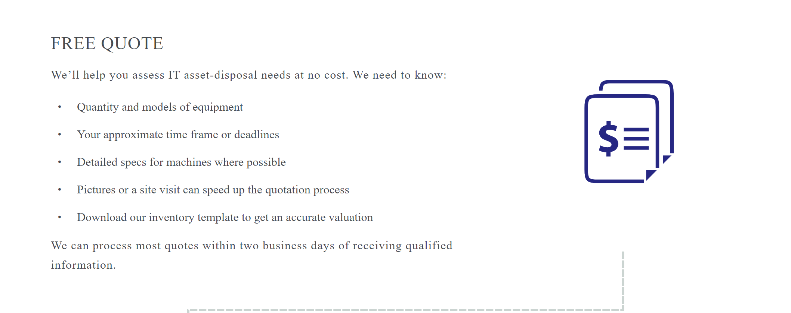
Visitors don’t have an opportunity to click on anything on the page until here.

This increases the chances of bounces or people exiting the page without doing anything.
Leveraging higher ranking keywords on this page would also be beneficial. IT equipment, for example, only has about 480 avg. monthly searches. While your company is niche, you should focus on keywords that will at least garner some traffic.

Meta Tags
Current meta title: IT Equipment Disposal: Understanding How We Do It
Updated meta title: IT Equipment & Computer Disposal & Recycling: Understand How We Do It
Current meta description: Explore the step by step IT equipment disposal process our team uses to handle projects from assessment to collection.
Updated meta description: View here the step-by-step IT equipment disposal and recycling process our team uses to handle projects from assessment to collection. See how we can help you.
Current H1: Removing, Liquidating, and Recycling Surplus IT Equipment
Updated H1: Removing, Liquidating and Recycling Surplus IT Equipment & Computers

